Save energy with Kaeser’s compressed air filtration
Kaeser recently launched its latest generation of high efficiency compressed air filtration products. End users can expect to enjoy significant energy savings with these filters thanks to a number of design enhancements that have resulted in up to a 50 percent lower pressure loss compared to other filters on the market.
The efficiency of a compressed air filter depends most of all on pressure loss. Kaeser Filter products house a number of features which together deliver high filtering efficiency and minimal pressure loss;
The element head of the Kaeser Filter units have been optimised for best possible air flow. Its tapered internal structure channels the compressed air to the centre of the element interior for even charging of the filter media. In addition, modern deep-pleated filter media is used in the Kaeser filter range to remove particles and aerosols, while a highly effective carbon fibre mat traps oil vapours. Together with innovative flow dynamics, this ensures exceptional filtration efficiency with minimal pressure loss.
Generously dimensioned connection flanges also assists in keeping pressure losses to a minimum. As Kaeser filter products are available with air connection flanges of various sizes, there is no need for reducer sections when connecting to different air distribution networks.
Kaeser Filter products demonstrate a lower pressure drop right from the outset compared to other typically available filters on the market. Moreover, the pressure drop remains low for much longer thanks to the high contaminant retention capacity. The result is low life time operating costs. In addition, the annual maintenance of particulate and coalescence filters mitigates age-related risks and ensures maximum compressed air purity.
Generously sized housings and filter surfaces, innovative flow dynamics and high performance filter media have all resulted in up to a 50 percent lower pressure loss in comparison to other filters on the market – a value that remains virtually constant throughout the entire service life of the filter element. This reduces the load on upstream compressors, thereby creating the potential for significant reductions in costs. As an example, just a 1 bar air pressure reduction can save up to 6 percent in compressed air associated energy costs. With this in mind it is possible to see how these intelligently engineered and generously sized filters can quickly pay for themselves by having a very low pressure differential.
Kaeser Filter products are dependable and efficient, characteristics that have been proven in the most sophisticated of testing environments and in stringent measurements programs. The impressive performance data of Kaeser Filter products have been determined in accordance with ISO 12500 and confirmed by the independent ‘Lloyd’s Register’ testing agency.
A service friendly design not only allows for simple and error-free opening and closing of the filter housing, but it also ensures quick and clean element changes. A practical bayonet lock ensures automatic positioning of the housing and element seals. Both seals are components of the filter element. This means that a filter housing can be sealed only if a filter element has been inserted. A locking screw prevents unintentional opening of the housing when under pressure and also provides housing venting.
Fitted as standard to Kaeser particulate and coalescence filters is a differential pressure gauge. This enables the user to monitor pressure losses – i.e. efficiency – at a glance. Unlike other commonly available systems on the market, the contaminated and clean air sides are isolated from one another.
Kaeser Filter product enclosures are cast from seawater-resistant aluminium. Several hundred hours of salt-spray testing have demonstrated their outstanding corrosion resistance. In addition Kaeser filter elements are protected by inner and outer cages made from continuously welded profile stainless steel. These cages are far more resistant to mechanical stress than those made from simple expanded material.
Manufactured to supply compressed air of all purity classes as per the ISO 8573-1 standard, Kaeser Filter products are available in four high performance filter grades and 12 housing sizes, providing efficient filtration for flow rates from 0.6 to 32.0 m³/min.

File: d-filters-aus
Approved for publication, copy acknowledgement appreciated
Image:

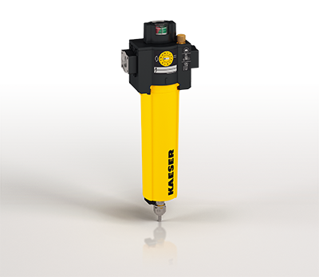
Save energy with Kaeser’s compressed air filtration
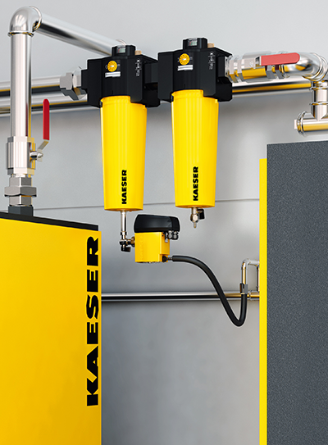
End users can expect to enjoy significant energy savings with these filters

