Kaeser quenches E’stel Water’s thirst for state-of-the-art high pressure compressed air technology
Growing product demand recently led premium alkaline water bottler E’stel Water to invest in a tailored and state-of-the-art Kaeser compressed air system, complete with a turn-key DN series booster to meet the high compressed air pressure requirements of their new PET blow molding machine.
E’stel Water is a premium alkaline water that is sourced and bottled in Nelson. The artesian water comes from the snow-capped mountains of New Zealand and travels underground where it filters through various minerals. 895 metres below the surface of the Waimea Plains in Nelson, E’stel then extract this high alkaline water, before transporting it to a modern purpose built bottling plant, where it is; bottled, capped, labelled and packed ready for global distribution.
The uniquely E’stel shaped plastic bottles that this high alkaline water is packaged in, are manufactured on site using a PET blow molding machine. As demand for E’stel Water has steadily grown since the company was established just 3 years ago, so has the requirements of the bottling plant. This led to the recent investment into a much larger capacity PET blow molding machine.
Responsible for manufacturing the water bottles, the PET blow molding machine relies on an efficient supply of compressed air. At certain points within the process, compressed air needs to be pressurised up to 40 bar. This inflates the soft PET (polyethylene terephthalate) plastic into a mold cavity which takes the desired shape and size of the water bottles. With a standard industrial compressor reaching around a 10 bar pressure, a booster compressor is therefore additionally required at those points in the production process where this high pressure compressed air is required, to literally boost, or increase, the air pressure up to the desired level of - in this case - 40 bar.
The new PET blow molding machine at E’stel is able to blow a staggering 11,000 bottles per hour (BPH). As it is a much larger system than what the company had previously, a new compressed air system was therefore required to meet this increased demand for compressed air.
Wayne Herring, Co-Founder and Director of E’stel Water, called upon existing and local compressed air specialist – and authorised Kaeser partner - PSL Total Air to present a suitable solution. In order to meet both the low and high pressure compressed air demand of the new PET blow moulding machine, PSL recommended and subsequently installed a complete compressed air system that included a Kaeser CSD 105 rotary screw compressor and a Kaeser DN 22 series booster.
Unlike other boosters on the market, the Kaeser DN 22 is a compact, plug and play turnkey package. These completely unique integrated booster systems are delivered and configured ex works to provide a system that is ready for immediate use.
All DN series Kaeser boosters are equipped with a premium efficiency IE3 class drive motors which complies with and exceed prevailing Australian GEMS regulations for 3 phase electric motors. Along with the generously dimensioned axial fan, which also assures reliable temperature control, this contributes to the booster’s cost effective energy usage.
For all round reliability, the DN series of boosters from Kaeser also come with an integrated Sigma Control 2 controller as standard, which delivers efficient control and monitoring of the compressor operation. This greatly simplifies the diagnostics process for precision service and maintenance work. They can also be connected to a monitoring system, such as the Sigma Air Manager 4.0 master controller, allowing full integration into an industrie 4.0 environment.
The Kaeser DN 22 series booster was the perfect high compressed air pressure solution for E’stel as Herring explains; ‘We already had two standard pressure Kaeser Aircenter compressed air systems being used for various other pneumatic applications within the facility, so we knew these compressors were reliable - something that is very important to our operation. When we started researching high pressure compressed air solutions, a lot of products on the market seemed to be manufactured using quite dated technologies, and the replacement of parts would have worked out to be very expensive. With the Kaeser DN 22 booster we were presented with a cost effective and state-of-the-art packaged solution. PSL was able to tailor a compressed air supply system to meet our exact needs, and it is already proving to deliver an energy efficient and reliable supply of compressed air on demand. Their after sales service has also been fantastic.’
The DN series of boosters from Kaeser are available with initial working pressures of 3 to 13 bar with final working pressure 10 to 45 bar, motor power 22 to 45 kW and free air deliveries 2.9 to 19.6 m³/min.

File: Q-Estel-Water-aus
Approved for publication, copy acknowledgement appreciated
Images: (contact the press office for high res copies of the following images)

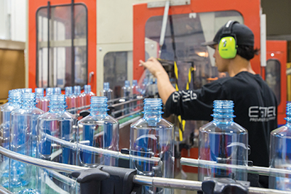
Caption: Responsible for manufacturing the water bottles, the PET blow moulding machine relies on an efficient supply of compressed air

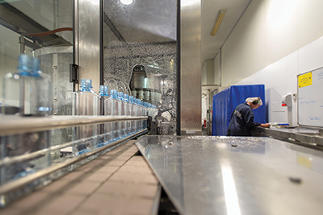
Caption: Compressed air is used to power the machines which fill the bottles with E’stel’s premium alkaline water

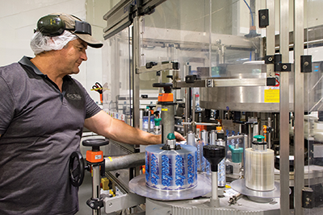
Caption: Compressed air is used to power the labelling machines at E’stel

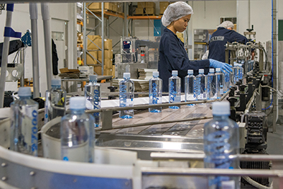
Caption: The modern purpose built bottling plant in Nelson where E’stel; bottle, cap, label and pack their artisan water ready for global distribution

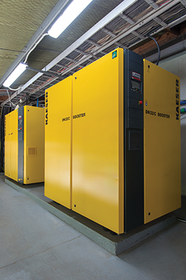
Caption: PSL installed a Kaeser CSD 105 rotary screw compressor and a Kaeser DN 22 series booster

