May 2022

Tap into the future of intelligent control today:
Kaeser announces latest developments to the SAM 4.0

The Sigma Air Manager 4.0 (SAM 4.0) compressed air management system from Kaeser Compressors has been continuously developed and enhanced ever since it was launched in 2001. Some 20 years later and the latest developments are now allowing end users to tap into the future of intelligent control today!

A key technology for Industrie 4.0, the Sigma Air Manager 4.0 (SAM 4.0) is an advanced master controller which can coordinate operation of multiple compressors - as well as dryers and filters - with exceptional efficiency. The latest round of developments announced by Kaeser, means that end users are now able to tap into the future of intelligent control way ahead of its time.

Action, not reaction
Today, master controllers are expected to do far more than just take care of demand-oriented compressor operation. Efficiency is playing an ever-increasing role. The days of rigid, inflexible rules are over. Fixed switching sequences can no longer be implemented in an energy-optimised manner to meet ever-changing demand requirements, as every fixed rule in an algorithm limits the controller’s flexibility and reduces its degree of freedom to act.

By monitoring and recording past compressed air consumption patterns, projections for future demand can be derived. On the basis of this demand projection, the technical conditions of the components and the learned knowledge regarding the system and its behaviour - the patented simulation-based optimisation process is used to anticipate the most efficient switching operations. Decisions are therefore no longer dictated by a narrow pressure band that must be adhered to. Rather, they are determined exclusively by the pursuit of achieving the lowest possible compressed air production costs, whilst maintaining the specified demand pressure and maximum pressure.

A digital helping hand for enhanced efficiency and increased reliability
Compressed air station digitalisation enhances energy efficiency and increases reliability. As all station components are in constant communication with one another, any performance deviations can be detected at an early stage and addressed.

The SAM 4.0 connects every component within the compressed air station - including external components - via the secure, IP-based Kaeser Sigma Network. As the central node point, it gathers the individual operating data and forwards them to mobile phones, laptops or tablets for browser-based viewing via Kaeser Connect. This not only provides comprehensive and remote station monitoring, but also enables operating data to be integrated into existing control technology. Flexible interface modules ensure easy on-site plug and play connection, for a continued overview of the production process.

Predictive maintenance for maximum availability
In order to simplify system maintenance, the SAM 4.0 menu has been expanded to include a ‘maintenance’ section. This new function allows the end user to view the maintenance hours counters for the compressors. Counter readings can be called up live, or sent via an automatically generated report.

This facilitates predictive and convenient planning of maintenance tasks. In addition, the SAM 4.0 always loads compressors within a maintenance group evenly, which also ensures that the maintenance hours for the corresponding systems are evenly distributed. This means that maintenance can be performed on these systems on the same day - or as one job - thereby limiting downtime.

In addition, when the SAM 4.0 is connected to the Kaeser Sigma Network, the Sigma Smart Air service package can be accessed. By providing operating, service and energy data for the entire compressed air system in real-time, the advanced services of tomorrow become available today - namely needs-based preventive maintenance and service. This ensures maximum dependability, reduced downtime and increased efficiency, which in turn saves both time and money.

The SAM 4.0 has an easy to read 12-inch colour display and a durable, easy-to-use touchscreen. Exceptionally user-friendly, it supports 34 languages. A simple software upgrade allows expansion of the master controller without the need for additional investment into new hardware. So, where the SAM 4.0 may have been initially capable of controlling only up to four compressors, it can be updated to control up to eight or even sixteen compressors. For more information visit au.kaeser.com or phone 1800 640 611.
-END- Free for publication, copy appreciated
Editors Notes
From 0.18 to 515 kW, Kaeser Compressors manufactures a wide range of compressors and associated auxiliary equipment that meet the varying requirements of a diverse range of industries and applications.
One of the world’s largest manufacturers of compressors, blowers and compressed air systems, Kaeser Compressors is represented throughout the world by a comprehensive network of branches, subsidiaries and authorised distribution partners in over 140 countries.

Kaeser Compressors Australia provides comprehensive sales and service from its purpose built factory in Dandenong, Victoria alongside an extensive network of sales and service centres and authorised partners that cover Australia and New Caledonia.

For editorial and advertising enquiries contact: Beth Wood, Marketing Manager
Press office: +61 3 9791 5999 E-mail: beth.wood@kaeser.com

KAESER COMPRESSORS Australia Pty Ltd
45 Zenith Road, Dandenong, VIC 3175, Australia
Phone: +61 3 9791 5999 Email: info.australia@kaeser.com
au.kaeser.com
File: M-SAM-4-0-Apr-22-aus
Approved for publication, copy acknowledgement appreciated
Images:
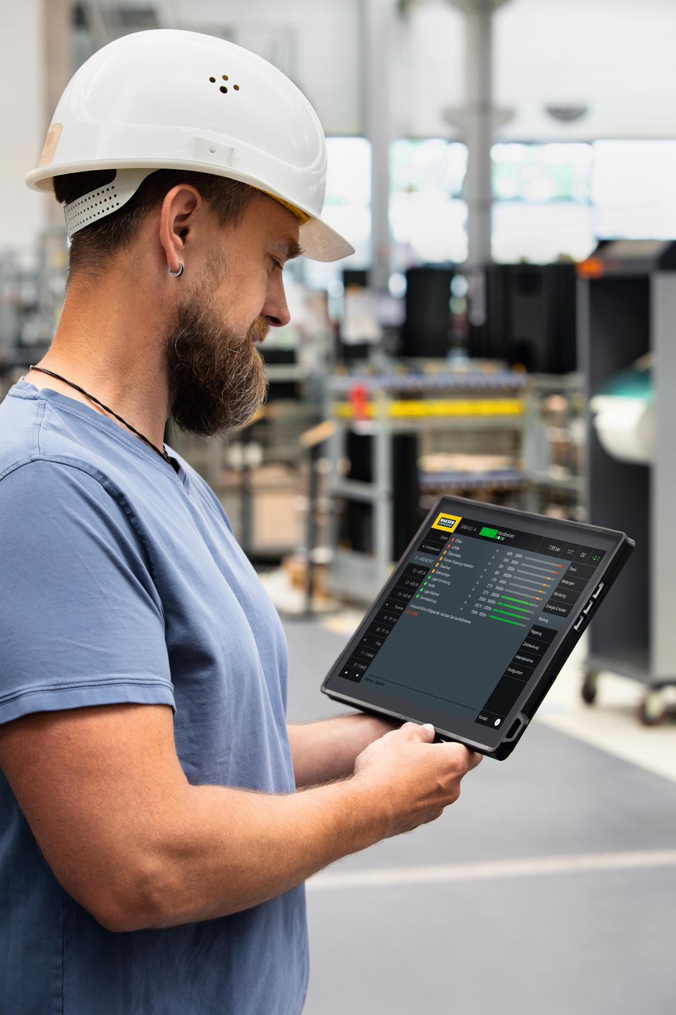
Caption: The SAM 4.0 connects every component within the compressed air station - including external components - via the secure, IP-based Kaeser Sigma Network. As the central node point, it gathers the individual operating data and forwards them to mobile phones, laptops or tablets for browser-based viewing via Kaeser Connect.
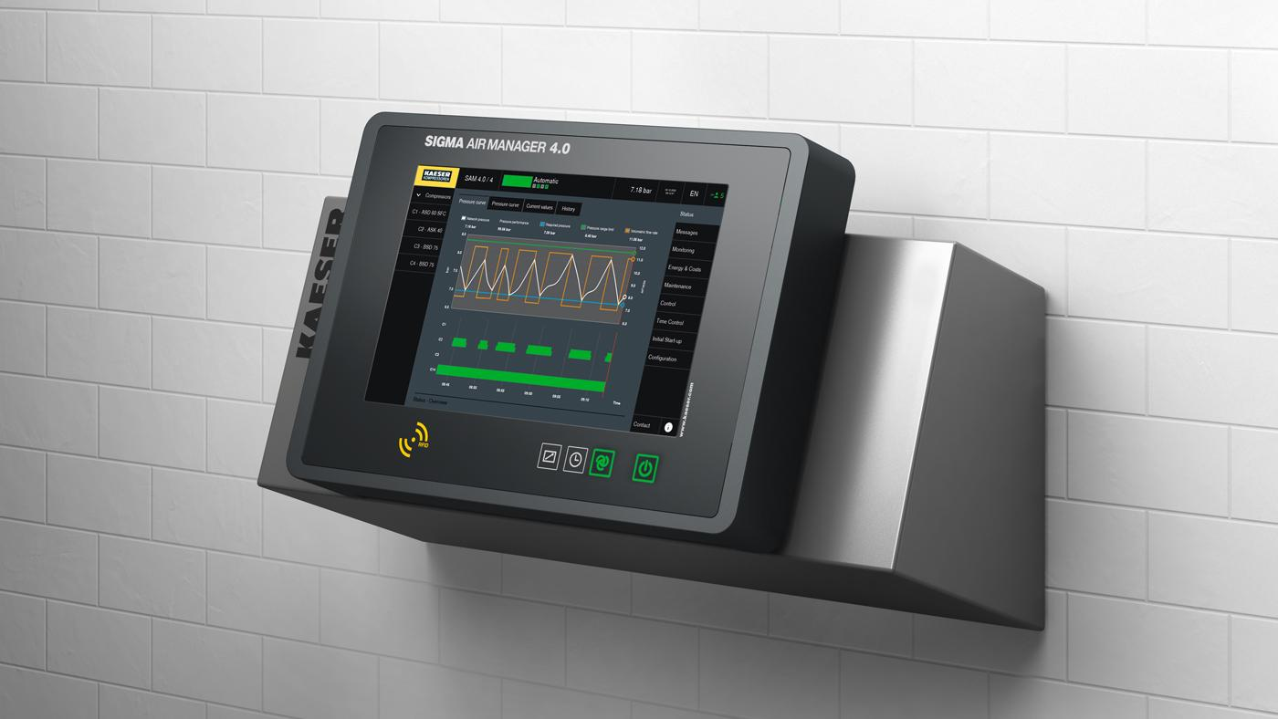
Caption: Launched over 20 years ago, the Sigma Air Manager 4.0 has been developed and enhanced ever since for maximum compressed air availability, reliability and energy efficiency.

((Kaeser photo – free for publication))

