A mobile and stationary portable compressor solution from Kaeser!
Where the compressed air user requires a mobile yet stationary portable compressor, Kaeser presents an altogether different hybrid solution - the diesel powered stationary M57 Utility rotary screw compressor.
The compact M57 Utility from Kaeser combines the advantages of a modern stationary screw compressor with the location flexibility of a portable compressor. Powered by a diesel engine, the unit does not require an external power supply, providing the user with a mobile but stationary portable compressor solution!
The M57 Utility was primarily developed to be installed as a stationary compressor on the flatbed of a truck. A fixed crane eye on the top of the unit's housing makes loading easy, whilst forklift pockets in the closed environmentally-friendly base frame ensure safe, dependable manoeuvrability via a fork-lift truck.
Equipped with an advanced rotary screw compressor, the M57 Utility provides outstanding performance, energy efficiency and user-friendliness. At the heart of each unit lies a durable rotary screw compressor block featuring the renowned Sigma Profile rotors, which use 15 percent less energy compared to conventional compressor block rotor designs.
In addition, Kaeser's highly efficient 1:1 drive design eliminates the transmission losses associated with gear or V-belt driven systems, as the compressor block is directly driven by a water-cooled, 4-cylinder Kubota diesel engine.
The M57 Utility from Kaeser boasts a number of additional distinct advantages including a compact design as well as exceptional power efficiency. All maintenance access points are easily accessible once the applicable retaining pins have been removed from the load floor side and fuelling is carried out from the front face of the unit. This is where the control panel, maintenance connections and three compressed air connections - all protected by a metal cover - are also located.
Reliability is further enhanced by the fuel filter with water separator that is fitted as standard, and the vertical discharge stainless steel exhaust pipe that also features a rain protection flap. Moreover, the wide range of available tools and accessories, such as screw-in machine feet, tool lubricators and compressed air after-coolers, also means that the system can be precisely tailored to suite the exact demands of the working environment.
Manufactured in Germany and built to Kaeser's renowned high quality standards, the M57 Utility is designed to provide many years of dependable service. With a drive power of 36 kW, the compressor has an effective free air delivery of 5.1 m³/min at 7 bar. The standard version is designed for operation which can be used to ensure a dependable supply of quality compressed air at ambient temperatures down to -25 ºC.

File: c-M 57 Utility-aus-2015
Approved for publication, copy acknowledgement appreciated
Image:

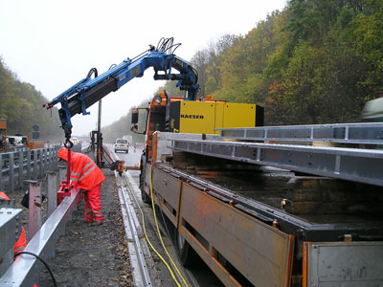
The compact M57 Utility from Kaeser combines the advantages of a modern stationary screw compressor with the location flexibility of a portable compressor

