Making significant energy savings with compressed air
With compressed air being one of the largest energy consumers to manufacturing, understanding how on-going energy efficiencies can be achieved is crucial to staying competitive. Kaeser Compressors explains more.
Over the past decade Australian manufacturers have seen a large surge in the price of electricity. Once seen as a relatively low fixed cost, energy has become an important variable cost that impacts on company profits. One of the largest of all energy consumers in a manufacturing facility will be the compressed air system.
Almost three quarters of the lifetime costs of a compressor are attributed to energy. If you take the example of a 250 kW compressor, running three shifts, seven days a week, with electricity costs at $0.10/kWh, over an average 10 year lifecycle that will cost $2.19 million to run in electricity costs alone! However, with most compressed air systems, only around 50 percent of the compressed air produced is actually production demand. With the example above, that means over $1 million is being potentially wasted through; compressed air leaks (estimated at 25-30 percent), artificial demand (estimated at 10-15 percent) and inappropriate uses (estimated at 5-10 percent).
The good news: many existing compressed air systems hide an energy savings potential of approximately 30 percent.
Assessment pays dividends
Without a doubt there are a number of product and service solutions on the market which may well assist a compressed air user in optimising their associated energy usage. However, the initial stage in optimising the energy efficiency of a compressed air system will be to identify how and where compressed air is currently used.
Initial energy savings can be identified by simply observing and listing what compressed air is actually used for. For example, is compressed air being used for tasks which could be performed more cost effectively without compressed air? Using a nozzle or gun for blowing or cleaning your workshop would be an example of an inefficient and inappropriate use of compressed air.
A more in depth look into the compressed air usage would also identify opportunities for energy savings. This may include reviewing the existing and future demand for compressed air. As an example, any changes to shift patterns and production patterns will impact the actual demand for compressed air. By measuring the systems load profile – or in other words the demand on the compressed air system over a defined period of time – it is also possible to identify how and where compressed air system performance and efficiencies can be made.
Compressed air leaks are an unavoidable by-product of running a compressed air system. However, if they are not managed, leaks can squander a large proportion of the compressed air produced by a compressor. Based on a compressor running 24/7 and a power cost of 10 cent/kW/hr, just one 2 mm diameter leak could cost over $1,300 per annum. Imagine the overall cost of only a few leaks!
Identifying, measuring and fixing air leaks could therefore play a significant role in reducing the associated all up energy costs. This can be achieved, for example, with the assistance of Ultra Sonic Leak Detection. Furthermore, implementing a leak management program, whereby leak detection is a regular part of the maintenance program, will ensure that the energy savings are long term.
Undergoing a compressed air system analysis carried out by a qualified compressed a specialist, will be the most comprehensive method to review a compressed air system and identify exactly where the opportunities for energy savings lie.
Prevention is better than cure
Aside from unplanned downtime and even product spoilage, it is also highly likely that energy costs will be unnecessarily elevated if a compressed air system is not well maintained. However, this can be avoided by simply following the Original Equipment Manufacturer’s (OEM’s) recommended maintenance schedule, using only genuine spare parts and selecting only authorised Service Technician’s to carry out maintenance work.
The consumables within a compressed air system may appear to be a seemingly small factor, however they play a significant role in the overall energy efficiency of a compressed air system. When faced with the decision of replacing consumables with OEM genuine spare parts or non-genuine – spurious – spare parts, it is worth considering that only genuine OEM spare parts have been rigorously tested by the OEM with the compressed air equipment. The durability, performance, efficiency, safety and even the compatibility of spurious parts will not have been tested with the compressed air equipment.
Maintaining the integrity of a compressed air system is critical to ensure that it continues to operate at its peak performance – reliably and efficiently. There is no way of knowing how spurious parts will interact and how they may affect the performance of compressed air equipment. They may compromise the reliability, safety of the equipment, the air quality required as well as the efficiency.
Opting for energy efficient technologies
In addition to optimising the energy efficiency of an existing compressed air system, many compressed air users may find that they can make significant energy savings by investing in energy efficient compressed air technologies.
Energy savings of approximately 10 percent are possible when users opt for compressors that include efficient airends, 1:1 drives and efficiency-optimised energy saving electric motors such as the IE3 class premium efficiency motors and the IE4 class super premium efficiency motors.
Where the demand for compressed air fluctuates, for example where production is completed in shifts, energy savings may be made by investing in a frequency controlled, or variable speed, rotary screw compressor. Here, only the exact amount of compressed air required is produced at any one time. This optimises the energy consumption.
Investing in a compressed air management system – or a master controller - is also a key technology that can assist users in energy efficiently managing multiple compressors. Master controllers nowadays should not only be capable of activating and deactivating compressors according to demand in order to minimise control-related losses, but should also provide comprehensive monitoring and preventive maintenance features. The ability to display air consumption and energy demand is also essential to ensure that utilisation is compliant with energy management regulations as per EN/ISO 50001.
Such advanced master controllers are also a key technology in the advanced world of Industrie 4.0, as the central mastermind that controls the entire compressed air supply system. In this ultra-flexible production environment, intelligently networked compressed air systems provide the optimal compressed air power and quality required, ensuring exceptional efficiency through continuous real-time monitoring and optimisation.
Conclusion
From assessing and making improvements to an existing compressed air system, to investing in energy efficient compressed air technologies, there are a number of avenues that compressed air users can explore in order to generate significant and on-going energy savings.

File: n-energy-savings-aus
Approved for publication, copy acknowledgement appreciated
Image:

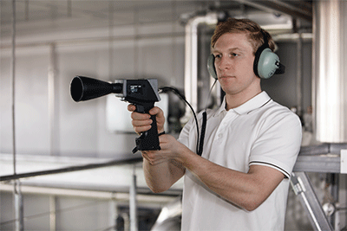
Identifying compressed air leaks with an Ultra Sonic Leak Detector

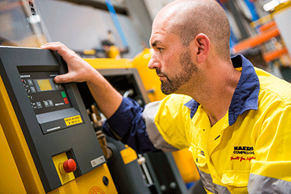
Energy efficiency can be optimised by following the OEM’s recommended maintenance schedule

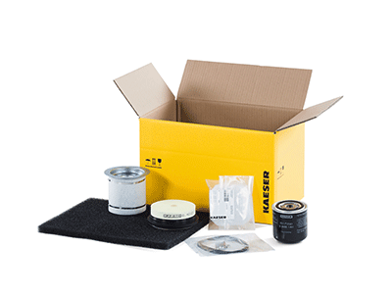
Choosing OEM genuine spare parts will impact the all up energy efficiency of the compressed air system

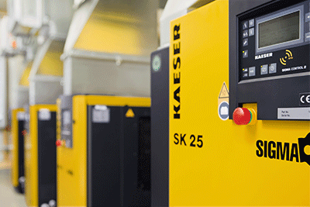
Energy savings can be made by opting for premium efficiency compressors

